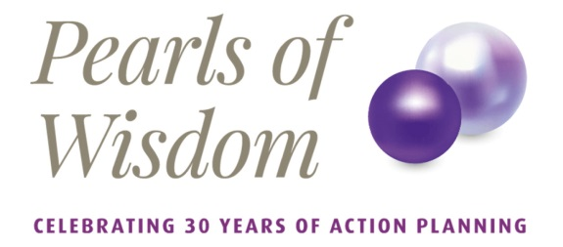

Online Application Form

Welcome to the Action Planning £100,000 Giveaway!
We just need you to answer 6 questions to see if you are eligible to apply.
1 | I am applying on behalf of a non-for-profit organisation (such as a charity, CIC/social enterprise, or non-profit Trust) registered and based in the UK. | Yes/No
2 | My organisation has an annual income of at least £200,000 and/or has at least two full time equivalent paid staff members in post. | Yes/No
3 | This application has the full and genuine support of my organisation's CEO and Chair. | Yes/No
4 | My organisation is able to host the delivery of this work within 6 months, or by the end of 2020, whichever is later. | Yes/No
5 | I confirm that my organisation agrees to pay any agreed out-of-pocket expenses incurred by the Associate Consultant in delivering the project. | Yes/No
6 | I confirm that my organisation agrees to be bound by the terms and conditions of the £100,000 Consultancy Giveaway as set out in the policy. | Yes/No
 | If you are able to answer YES to the above questions, you are eligible to apply for Action Planning's £100,000 Consultancy Giveaway!
7 | Please tell us the Name, Registered Address and Legal Structure (including Charity Number if applicable) of your organisation | Name:  Registered address:  Legal structure:  Charity number if applicable:
8 | Please tell us the Lead Person's Name, their Position and Contact Details.  Including their phone number, email address, website and physical address if different from the previous question. | Contact name:  Position:  Phone number:  Email address:  Website:  Physical address:
9 | And now please tell us what your organisation does. | (max 250 characters)
Now we're going to ask you about the type of Consultancy you would like to apply for.
You have up to three preferences.
10 | Your first preference: Please choose your project | (Please choose your first preference from our list of projects)
11 | Please explain why you have selected this project, including the need for, and impact of, the project on your organisation | (Max 600 characters)
12 | Your second preference: Please choose your project | (Please choose your second preference from our list of projects)
13 | Please explain why you have selected this project, including the need for, and impact of, the project on your organisation | (Max 600 characters)
14 | Your third preference: Please choose your project | (Please choose your third preference from our list of projects)
15 | Please explain why you have selected this project, including the need for, and impact of, the project on your organisation | (Max 600 characters)
The information provided in this application will be shared with Associate Consultants who are registered with Action Planning for the purposes of selecting and implementing the projects and the £100,00 Consultancy Giveaway.
We would like to also use your contact details to send you our newsletter and other information about our services from time to time.
16 | Please tick the 'yes' to confirm your agreement to this | Yes/No
 | By applying, the applicant confirms acceptance of the terms and conditions and detailed in the £100,000 Consultancy Giveaway Policy.
17 | Please put your name and date below as a digital signature.

Please fill out the online form available on https://pearlsofwisdom.actionplanning.co.uk/ and use this document as a reference only. Please refer to our T&Cs and note that Action Planning will only accept online applications.

